Real life example of polymorphism
Suppose if you are in class room that time you behave like a student, when you are in market at that time you behave like a customer, when you at your home at that time you behave like a son or daughter, Here one person present in different-different behaviours.
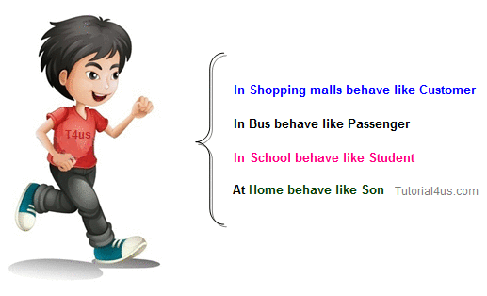

Person
behave() – virtual method

Customer Student Son
behave()- like a customer behave()- like a student behave()- like a son

